1. Algorithm countdistinct(A,n)
2. {
3. distinctcount:=0 ---->1
4. for i:=0 to n do ---->sum i=0 to n
5. Isdistinct:=true ---->1
6. for j:=0 to I do ---->sum j=0 to i
7. If A[i] == A[j] then ---->1
8. Isdistinct:=false ---->1
9. Break ---->1
10. If isdistinct==true then ---->1
11. distinctcount=distinctcount+1 ---->1
12. return distinctcount ---->1
13. }
14. ==========================================
15. ANALYSIS
16. 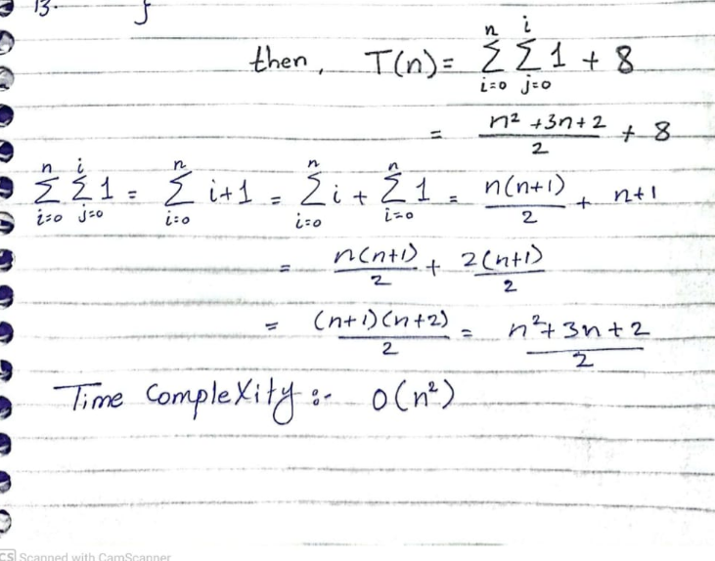
17. ===================================================
18. TIME COMPLEXITY
19. Best-case time complexity is O(n)

20.Worst-case time complexity is O(n^2)

21.Average-case time complexity is O(n^2)